Sorry we missed you!
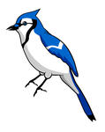
The summer camp blue jays are at:
__________________
Call or email Erin if you need immediate assistance

